Git Assignment

1) create two files - student.txt and employee.txt and add them to staging area  
2) add one more file - dept.txt into staging area but at same time restore the employee.txt and modify some changes inside the student.txt   
3) push dept.txt and employee.txt to the remote repos  
4) create a new file - hello.txt in remote repos directly and bring to the working directory  
5) send all files from working directory to remote repos  
6) remove a file from the remote repos and sync the changes into your working directory

Step 1:

Step 2:

Step 3:

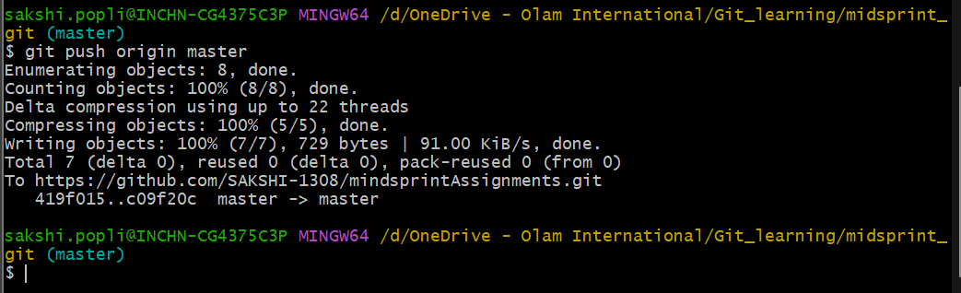

Step 4:

Step 5:

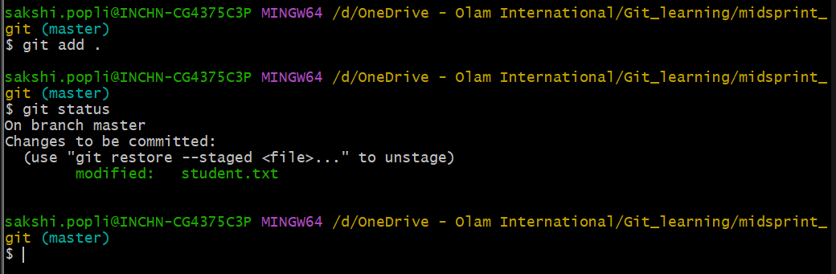

Step 6:

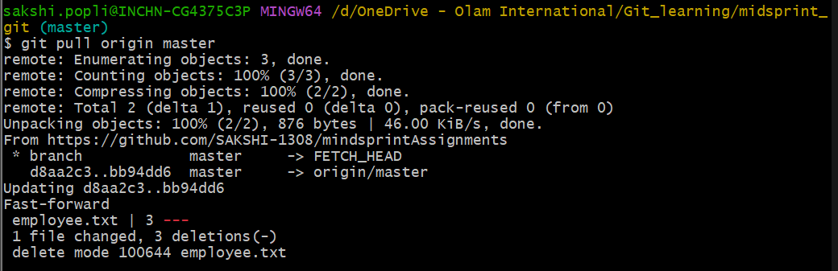

Final output in git:

